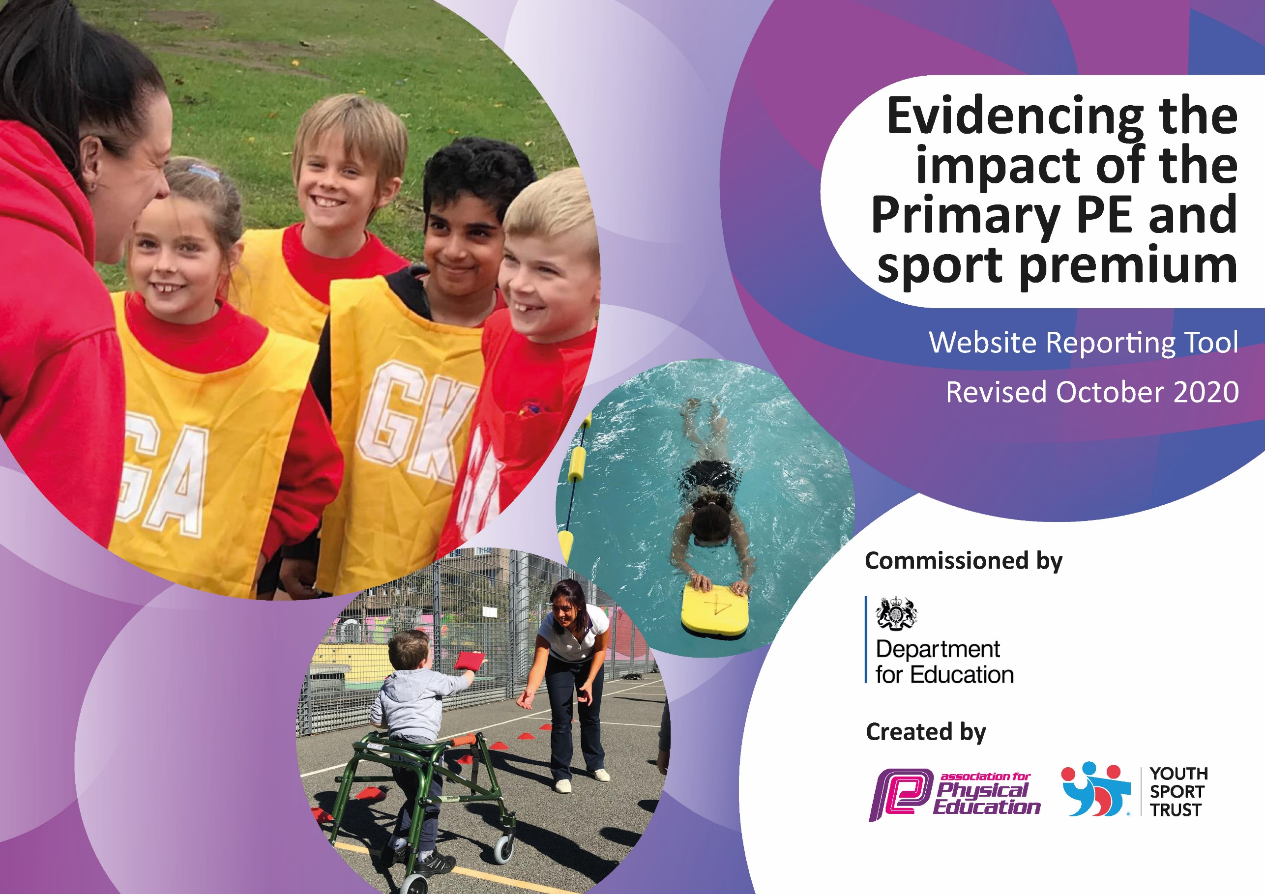
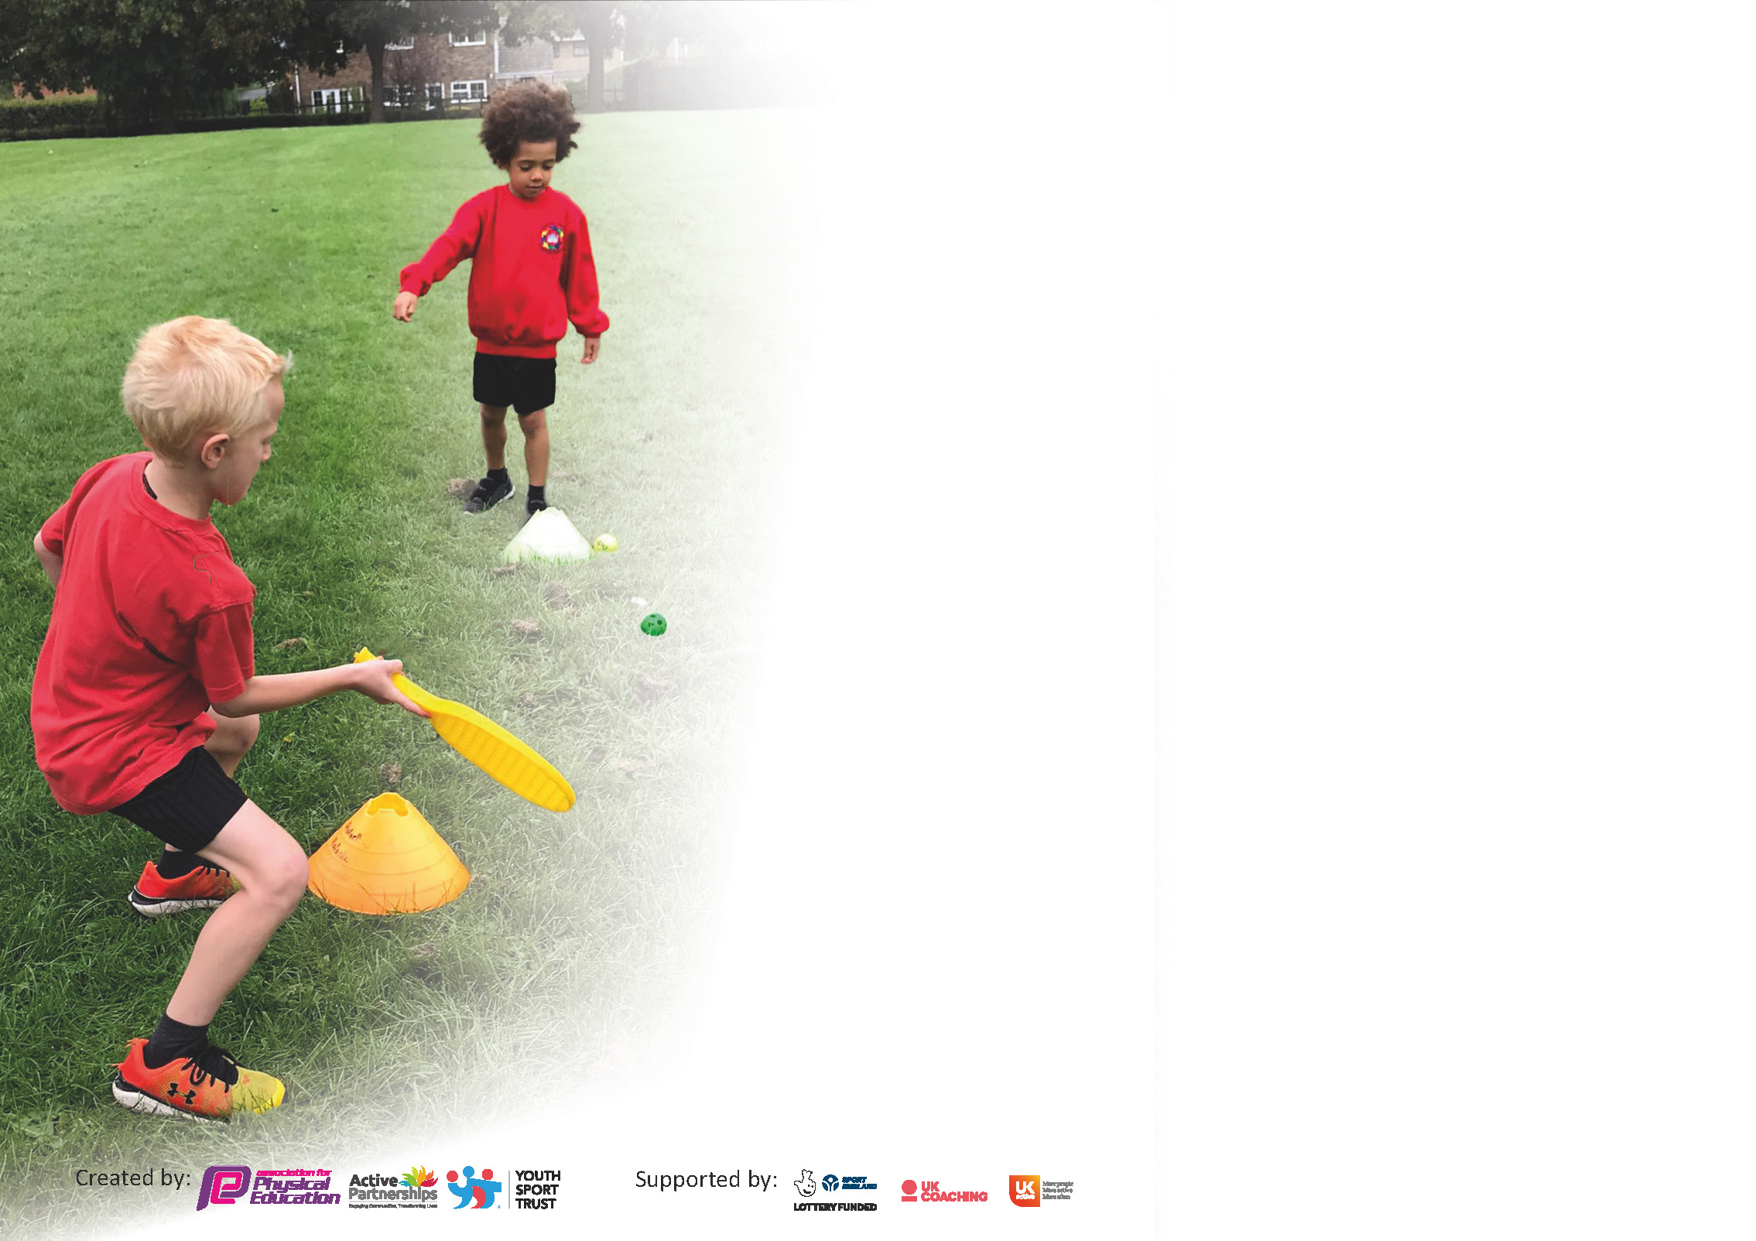

It is important that your grant is used effectively and based on school need. The Education Inspection Framework (Ofsted 2019 p64) makes clear there will be a focus on ‘whether leaders and those responsible for governors all understand their respective roles and perform these in a way that enhances the effectiveness of the school’.

Under the Quality of Education criteria (p41) inspectors consider the extent to which schools can articulate their curriculum (INTENT), construct their curriculum (IMPLEMENTATION) and demonstrate the outcomes which result (IMPACT).

To assist schools with common transferable language this template has been developed to utilise the same three headings which should make your plans easily transferable between working documents.

Schools must use the funding to make additional and sustainable improvements to the quality of Physical Education, School Sport and Physical Activity (PESSPA) they offer. This means that you should use
the Primary PE and sport premium to:

- Develop or add to the PESSPA activities that your school already offer
- Build capacity and capability within the school to ensure that improvements made now will benefit pupils joining the school in future years

Please visit gov.uk for the revised DfE guidance including the 5 key indicators across which schools should demonstrate an improvement. This document will help you to review your
provision and to report your spend. DfE encourages schools to use this template as an effective way of meeting the reporting requirements of the Primary PE and sport premium.

We recommend you start by reflecting on the impact of current provision and reviewing the previous spend.

Schools are required to publish details of how they spend this funding as well as on the impact it has on pupils’ PE and sport participation and attainment by the end of the summer term or by 31st July 2021 at the latest.

** In the case of any under-spend from 2019/20 which has been carried over this must be used and published by 31st March 2021.

We recommend regularly updating the table and publishing it on your website throughout the year. This evidences your ongoing self-evaluation of how you are using the funding to secure maximum, sustainable impact. Final copy must
be posted on your website by the end of the academic year and no later than the 31st July 2021. To see an example of how to complete the table please click HERE.
Created by: Supported by:

Please note: Although there has been considerable disruption in 2020 it is important that you publish details on your website of how you spend the funding - this is a legal requirement.
Support for review and reflection - considering the 5 key indicators from DfE, what development needs are a priority for your setting and your pupils now and why? Use the space below to reflect on previous spend and key achievements and areas for development.

N.B. In this section you should refer to any adjustments you might have made due to Covid-19 and how these will influence further improvement.
Key achievements to date until July 2020: | Areas for further improvement and baseline evidence of need:
- Participation levels in after school clubs have increased.  - The school has provided a variety of sports clubs(chosen by children changing half termly)  - Professional gymnastics coaching provided  - Participation in a variety of school sport competitions across Halton has increased.  - The school has retained the GOLD School Games mark  - Improving the quality of teaching in physical education with LFC foundation supporting teacher CPD and every member of staff now FA trained to deliver sport  - Inclusion of sporting achievements through social media  - Introduction of table tennis tables and equipment  - Constant replenishing of playground equipment  - Purchase of bikes and scooters in ks1 to develop gross motor skills  - Purchase of netball posts to introduce children to netball  - Introduced and delivered Active Maths and Active SPAG  - Trained all teachers to deliver yoga  - Professional dance teacher employed as TA and taking extra-curricular dance club | - Improvements of opportunities for intra sport competitions through use of sports leaders in school  - Improve the involvement in inter school games  - Introduce tennis, volleyball and badminton equipment and clubs  - Win Gold in school games award for 2020-2021  - Further improve the variety of extracurricular clubs ensuring all children take part (school council involved in choosing)  - To improve further the activity of all children daily in school  - Promote 120 active minutes across the school  - School to maintain gold standard at school games  - Continue to promote gymnastics through professional coach  - CPD training for all staff in gymnastics  - Every child to swim 50metres before the end of Y6

Did you carry forward an underspend from 2019-20 academic year into the current academic year? YES/NO * Delete as applicable

If YES you must complete the following section
If NO, the following section is not applicable to you

If any funding from the academic year 2019/20 has been carried over you MUST complete the following section. Any carried over funding MUST be spent by 31 March 2021.
Academic Year: September 2020 to March 2021 | Total fund carried over: £6,700 | Date Updated:  July 2021
What Key indicator(s) are you going to focus on? |  |  |  | Total Carry Over Funding:
 |  |  |  | £6,700
Intent | Implementation |  | Impact | Total spent: £3,335
Your school focus should be clear how you want to impact on your pupils.  Provide an outdoor playground resources bag for each class. Class teachers will be responsible for the cleaning and care of the equipment.  Bag of 10 footballs  Provide all pupils with high quality, progressive PE and sport in school. Children will benefit from good quality teaching from PE specialist and teachers.  Develop provision for physical activity at lunchtime by; Increasing the amount of playground resources to provide playground activity facilitated by MDS’s and year 6 sports leaders. | Make sure your actions to achieve are linked to your intentions:  Each class to have their own equipment to encourage physical activity at playtime.  KS2 children to play football matches and play in competitions  - Staff provided with weekly CPD training from LFC professionals  - Children from Y1-Y6 are provided with 1 hour high quality PE session with LFC  - Children can attend football breakfast/lunch club with LFC  Year 6 sports leaders trained in Playground Games.  - Create activity schedule so sports leaders are able to maximise physical activity at lunchtime  - Equipment and resources to be bought for facilitation of activity with sports leaders and independent play with resources including bikes and scooters  - New lunch club every Thursday – different sport every 6 weeks.  New morning active club – spring and summer term: KS1; fitness/ athletics | Carry over funding allocated:  £775  £70  £2250  £240 | Evidence of impact: How can you measure the impact on your pupils; you may have focussed on the difference that PE, SS & PA have made to pupils re-engagement with school. What has changed?:  Each class was provided with a playground resources bag for them to use at playtimes. Each bag had a range of outdoor equipment to encourage physical development at break times. Children have thoroughly enjoyed using these and it has made playtimes more enjoyable for them.  These were bought to prepare KS2 children for football competitions and for afterschool football clubs however neither of these could go ahead due to covid. Children were able to use footballs in their playground kits to play games during break times.  - LFC provided weekly lessons across the whole school. Children received high quality lessons in PE each week whilst developing their team work and collaboration.  - Staff received high quality CPD which they have been able to use in their own PE lessons.  - LFC facilitated a fantastic sports day for KS1 and KS2. The two sessions were filled with fun sports and games that were inclusive for all children.  - Unfortunately we could not have a breakfast/lunch club this year due to covid.  We purchased equipment to hold a range of clubs at lunchtime however due to covid we were unable to facilitate this. Children facilitated games and sports within their own classes however this will be a target for next year to ensure children are provided with a range of different sports clubs. | Sustainability and suggested next steps and how does this link with the key indicators on which you are focussing this academic year?:  Ensure bags are filled with good resources and these are enhanced every half term. Use children understand how to appropriately use equipment e.g. cricket bats and balls for cricket. Teachers could model a few games and sports in Autumn term or when new equipment is put out to encourage children to play appropriately and look after items.  Football after school/ lunchtime club for ks1 and ks2 children to help prepare for intra and inter competitions next year.  - We have a fantastic relationship with the LFC foundation and look forward to working with them again next year.  - Provide afterschool/ lunch time clubs again to encourage sports outside of school.  - Speak with LFC and ask for suggestions for other sporting coaches e.g. tennis, cricket, basketball that could come to deliver CPD to staff and hold after school clubs.  Lunchtime/ after-school clubs in  - Cricket  - Badminton  - Gymnastics  - Tennis  - Table tennis  - Football  - Basket ball  - Volleyball

Meeting national curriculum requirements for swimming and water safety.  N.B Complete this section to your best ability. For example you might have practised safe self-rescue techniques on dry land. | Unable to complete any swimming lessons this year due to covid.
What percentage of your current Year 6 cohort swim competently, confidently and proficiently over a distance of at least 25 metres?  N.B. Even though your pupils may swim in another year please report on their attainment on leaving primary school at the end of the summer term 2020. | %
What percentage of your current Year 6 cohort use a range of strokes effectively [for example, front crawl, backstroke and breaststroke]? | %
What percentage of your current Year 6 cohort perform safe self-rescue in different water-based situations? | %
Schools can choose to use the Primary PE and sport premium to provide additional provision for swimming but this must be for activity over and above the national curriculum requirements. Have you used it in this way? | Yes/No

Action Plan and Budget Tracking
Capture your intended annual spend against the 5 key indicators. Clarify the success criteria and evidence of impact that you intend to measure to evaluate for pupils today and for the future.

Academic Year: 2020/21 | Total fund allocated: £16, 790  Total spent: £12,475 | Date Updated: July 2021
Key indicator 1: The engagement of all pupils in regular physical activity – Chief Medical Officers guidelines recommend that primary school pupils undertake at least 30 minutes of physical activity a day in school |  |  |  | Percentage of total allocation:
 |  |  |  | %
Intent | Implementation |  | Impact
Your school focus should be clear what you want the pupils to know and be able to do and about  what they need to learn and to  consolidate through practice: | Make sure your actions to achieve are linked to your intentions: | Funding allocated: | Evidence of impact: what do pupils now know and what can they now do? What has changed?: | Sustainability and suggested next steps:
Headline Intended Impact on  Pupils – All pupils will be active on average 60 minutes a day, 7days a week.  Provide a range of activities - implementation of new extracurricular timetable. Increase the number of clubs for children. | Increasing the range of clubs provided;  - Gymnastics, tennis, games, dance. Provide a lunchtime club running on a 6 weekly timetable. (A different sport every 6 weeks) Purchase of tennis and volleyball kits and net.  - Working and liaising with more providers and sports clubs  Pupil needs/interests (Pupil Voice) –pupil questionnaires to be monitored by new Sports leaders. | N/A | Unfortunately due to covid, we were advised not to hire any external coaches to come into schools. We were also not allowed to cross bubbles which meant that we could not hold inter class competitions. We need purchase equipment however it was advised not to be used. | - Set up safe clubs at lunch times using the equipment with a range of sports.  - Get in external coaches to facilitate morning/ lunchtime clubs for children.  - Conduct pupil voice survey to see what sports/ activities children are interested in  - Develop sports leaders across the whole school.
Introduce a dance morning to be held once/twice a term; increasing parental involvement and promoting health and fitness. | - Provided whole school dance morning where children and parents join in with simple dance routines to help wake up, get energised and improve quality of learning.  - Increase interest in fitness and exercise and bring the community together. | £175 | We were unable to provide a dance fitness morning due to covid.  In summer term, we did hire a coach to come in twice a week and deliver fitness classes for parents to involve physical activity and wellbeing. | We did not have a great turn out as a lot of parents were still afraid to mix due to covid.  Next year, it would be nice if we could introduce a family fitness class after school to encourage more physical activity at home.
Purchase a trim tail for EYFS playground to support gross motor skills and enhance physical development. | - Purchase of a trim trail in the EYFS outdoor area  - Increase KS1 children’s engagement with outdoor learning  - Develop problem solving and team building skills  - Support gross motor skills of EYFS and KS1 children  - Encourage children to take risks | £12,000 | To be installed in September. | This has not yet been installed however it will be in September. This will give children the opportunity to promote outdoor learning and build gross motor skills ready to beginning PE and sports in Key Stage One.
Key indicator 2: The profile of PESSPA being raised across the school as a tool for whole school improvement |  |  |  | Percentage of total allocation:
 |  |  |  | %
Intent | Implementation |  | Impact
Your school focus should be clear what you want the pupils to know and be able to do and about  what they need to learn and to  consolidate through practice: | Make sure your actions to achieve are linked to your intentions: | Funding allocated: | Evidence of impact: what do pupils now know and what can they now do? What has changed?: | Sustainability and suggested next steps:
Headline Intended Impact on pupils – All pupils’ personal development will be celebrated.  Supporting the target for all pupils to be active on average 60 minutes a day, 7 days a week.  Introduce PE and School sport  to Celebration assembly every term to ensure the whole school is aware of the importance of PE and Sport and to encourage all pupils to aspire to being involved in the assembles. | - Outside school achievements to be celebrated during celebration assemblies to increase interest in joining sports clubs.  - Classes to showcase PE learning during class assemblies e.g. dance/gymnastics  - Any PE achievements celebrated e.g. gymnast of the week or person of the match.  Celebrate achievements during active clubs and LFC sessions. |  | Outside school achievements were celebrated in classroom but not throughout school as we were unable to cross bubbles.  A lot of children’s clubs outside of school were not open due to covid. | - Outside school achievements to be celebrated during celebration assemblies to increase interest in joining sports clubs.  - Classes to showcase PE learning during class assemblies e.g. dance/gymnastics  - Any PE achievements celebrated e.g. gymnast of the week or person of the match.  Celebrate achievements during
Promote physical activity outside of school and celebrate | - Celebrate successes of outside sporting clubs on face book, Instagram and twitter as well as during celebration assemblies  - Organise for pupils to bring in photographs/ trophies/ awards which can be shown off in assemblies |  | We have moved away from social media due to misuse from parents and therefore post all achievements on our school website and twitter. These achievements have been celebrated in classrooms. | Bring forward targets to next year:  - Celebrate successes of outside sporting clubs on face book, Instagram and twitter as well as during celebration assemblies  - Organise for pupils to bring in photographs/ trophies/ awards which can be shown off in assemblies
Challenge attendance through the addition of new child fitness club. | Increase the number of before school active clubs to encourage pupils who are often absent or late to get into school on time. |  | Unable to complete due to covid. | Bring forward target to next year:  - Increase the number of before school active clubs to encourage pupils who are often absent or late to get into school on time.
Sport Leaders to be elected democratically September 2020. 2 children from Y6. | - Polling Day in September to elect School Leadership team and Sport Leaders.  - Sports leaders to shadow sports coaches in running school clubs  - Later in the year, leaders to run their own sports clubs and events  - Sports leaders to look after storage of equipment |  | We elected sports leaders but they were unable to be sports leaders across the whole school.  Instead each class had sports leaders who were in charge of looking after the equipment and suggested sports and games to play and facilitate and lunch and break times. | Develop sports leaders across the whole school and give them more opportunities to lead games and competitions.

Key indicator 3: Increased confidence, knowledge and skills of all staff in teaching PE and sport |  |  |  | Percentage of total allocation:
 |  |  |  | %
Intent | Implementation |  | Impact
Your school focus should be clear | Make sure your actions to | Funding | Evidence of impact: what do | Sustainability and suggested
what you want the pupils to know | achieve are linked to your | allocated: | pupils now know and what | next steps:
and be able to do and about | intentions: |  | can they now do? What has
what they need to learn and to |  |  | changed?:
consolidate through practice:
Headline Intended Impact on Pupils – All pupils’ will receive 2 hours high quality physical education every week. 100% of pupils will be developed in their physical, cognitive, social and emotional learning. Supporting the target for all pupils to be active on average 60 minutes a day, 7 days a week.  Provide gymnastics CPD training for all staff to increase confidence and subject knowledge.  Introduce an extra 1 hour slot of PE to every class’s timetable. | - Provide specialist in gymnastics to deliver high quality CPD training to all staff  - Work alongside class teachers to ensure that every class has another hour slot of PE that will be delivered by their class teacher  - Make a planning/curriculum overview for the year to ensure that the curriculum is being covered correctly. | N/A | Unable to complete due to covid.  In July 2019, after completing a subject knowledge survey, staff commented that they lacked confidence and knowledge to deliver gymnastics to a high-quality. Therefore, it was crucial to provide exceptional CPD to all staff.  All staff have been providing children with an additional PE slot each week. All staff have followed a yearly overview written by subject leader to ensure correct curriculum coverage. Children have been given fantastic opportunities to develop skills in gymnastics, dance, running, jumping alongside learning a range of sports. | Move target forward to next year.  - Provide specialist in gymnastics to deliver high quality CPD training to all staff  To continue this next year and have coverage monitored by subject lead.  Conduct pupil voice to see which lessons children enjoy best and why.
Key indicator 4: Broader experience of a range of sports and activities offered to all pupils |  |  |  | Percentage of total allocation:
 |  |  |  | %
Intent | Implementation |  | Impact
Your school focus should be clear | Make sure your actions to | Funding | Evidence of impact: what do | Sustainability and suggested
what you want the pupils to know | achieve are linked to your | allocated: | pupils now know and what | next steps:
and be able to do and about | intentions: |  | can they now do? What has
what they need to learn and to |  |  | changed?:
consolidate through practice:
Additional achievements:  Headline Intended Impact on Pupils – All pupils’ will be exposed to new areas of activity. Supporting the target for all  pupils to be active on average 60  minutes a day, 7 days a week  Continue to offer a wider range of activities both within and outside the curriculum in order to get more pupils involved. | - Additional Sports on offer – curriculum time to engage all pupils – Dance, gymnastics, hockey, tag rugby  - Extra-curricular – tennis, volleyball, badminton, fitness, multi-skills  - Arrange a pupil survey to see what sports/clubs they would like  - External coach to teach team sports in extra-curricular clubs e.g. cricket, gymnastics |  | We had no after school clubs this year due to covid. | Bring forward targets to next year.  - Additional Sports on offer – curriculum time to engage all pupils – Dance, gymnastics, hockey, tag rugby  - Extra-curricular – tennis, volleyball, badminton, fitness, multi-skills  - Arrange a pupil survey to see what sports/clubs they would like  - External coach to teach team sports in extra-curricular clubs e.g. cricket, gymnastics

Key indicator 5: Increased participation in competitive sport |  |  |  | Percentage of total allocation:
 |  |  |  | %
Intent | Implementation |  | Impact
Your school focus should be clear | Make sure your actions to | Funding | Evidence of impact: what do | Sustainability and suggested
what you want the pupils to know | achieve are linked to your | allocated: | pupils now know and what | next steps:
and be able to do and about | intentions: |  | can they now do? What has
what they need to learn and to |  |  | changed?:
consolidate through practice:
Headline Intended Impact on Pupils – Increase the number of pupils participating in an increased range of competitive opportunities Supporting the target for all pupils to be active  on average 60 minutes a day, 7 days a week  Be a part of school games  Increased participation in intra- competitions | - Implement an effective system for engaging in competition in lesson time. This means there will be an in class competition for all classes at the end of each unit of work.  - Competitive games introduced in active/sporting clubs and during LFC weekly lessons  - In summer term – sports leaders to organise a table tennis tournament for each class. | £600 | We were unable to complete these due to covid. | - Implement an effective system for engaging in competition in lesson time. This means there will be an in class competition for all classes at the end of each unit of work.  - Competitive games introduced in active/sporting clubs and during LFC weekly lessons  - In summer term – sports leaders to organise a table tennis tournament for each class.
Increased participation in inter-competitions | - Compete against local schools throughout the year in a range of different sports, including; cricket, football, dance, badminton |  | We were unable to participate in any competitions this year due to covid. | - Compete against local schools throughout the year in a range of different sports, including; cricket, football, dance, badminton
Retain gold mark in schools games award | - Increased participation in competitions; intra and inter  - Increased range of clubs and sports for KS1 and KS2  - Parental involvement in dance mornings  - CPD training for staff to improve subject knowledge |  | We participated in some online challenges and activities through school games however this was very limited due to covid. The gold mark has been retained until next year when we can start again properly. | Bring forward targets from this year:  - Increased participation in competitions; intra and inter  - Increased range of clubs and sports for KS1 and KS2  - Parental involvement in dance mornings  - CPD training for staff to improve subject knowledge

Lockdown 2021
- Live gymnastics lessons with Warrington gymnastics club weekly
- Friday FIT HIIT class for KS1 children weekly
- Joe Wicks used twice weekly for PE across school
- Just Dance used in K2
- Cosmic kids yoga KS1 weekly
- Phone call with Jo from school games – discussion of school games marks and what we need to do. Keeping gold mark. Implement games/ sports/ activities and encourage physical movement during remote learning.

Total to be carried over until July 2022: £7,380
2019-2020: £3,365
2020-2021: £4,015

Signed off by
Head Teacher:
Date:
Subject Leader: | Niamh Connor
Date: | 07.07.21
Governor:
Date:

