St Augustine’s Catholic Primary School

RSE

A Guide for Parents and Carers
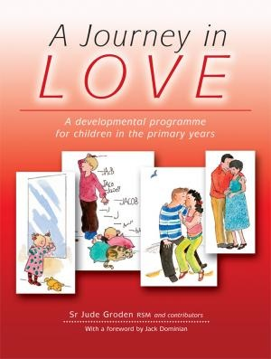

Aims of RSE
- To encourage pupils’ growth in self-respect, acknowledging we are all created in the image and likeness of God

- To help pupils develop an understanding that love is the central basis of relationships

- To help pupils to understand the nature of relationships and to encourage them to reflect on their own relationships and respect differences between people.

- To develop pupils’ confidence in talking, listening and thinking about feelings and relationships.

- To help pupils acquire the skills necessary to develop and sustain relationships

- To offer sex education in the wider context of relationships.

- To ensure that pupils protect themselves and ask for help and support when needed.

- To ensure that pupils are prepared for puberty.

- To help pupils to develop a healthier, safer lifestyle.

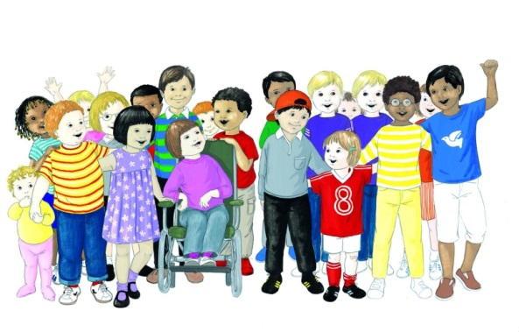
- To prepare pupils to play an active role as citizens and to understand the Catholic vision of what it means to be citizens of the Kingdom/reign of God.

How can I help?
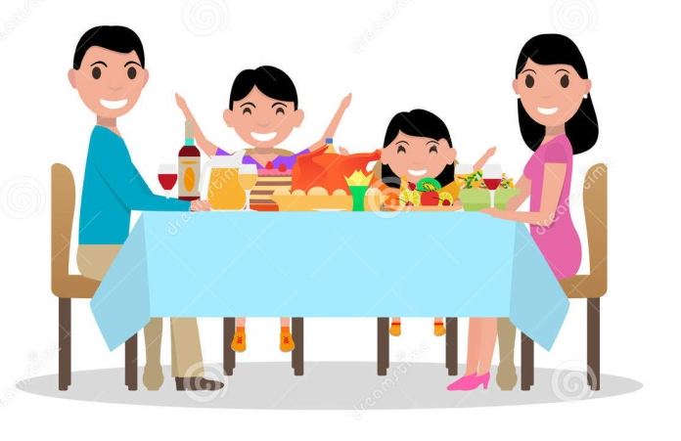
- by talking with your child at home,
- by discussing their work after each lesson
- by listening to any concerns,
- by reassuring your child that you are there if they need to talk about anything at all,
- by helping with homework activities,

We recognise parents as the first and most important educators of their children and we hope that the information provided here will enable us all to work together in supporting parents in their most important role.

What if I don’t feel that my child is ready for this programme of work?
We ask that if parents feel that their child may not be quite ready for the content within the programme, they should make an appointment with the Head Teacher or Deputy to discuss their thoughts on the matter.

Nursery - Wonder at God’s love
Children begin to know and understand that they are part of the wonder of God’s love and creation.

Key Words: God, wonder, love, creation, hands, fingers, nails, faces, noses, lips, ears, hair, features, colour, shape, size

Physical Children focus on their hands e.g. size, length of fingers, nails. They focus on each other’s eyes and note the colour and shape, they look at their faces and whole body shapes, size, shape and features.

Social Children look at their pictures and discuss how they are the same/ different and that each one is special. They discover how many boys and girls there are in the class and divide into groups for a play activity.

Emotional Children begin to observe and become sensitive to facial expressions. They focus on individual expressions and discover the beauty of their smile.

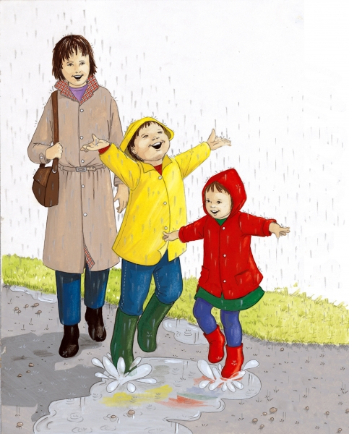
Spiritual Children focus on the wonders of God’s world, e.g. people, animals, trees, land, seas etc. They see their special place as part of the wonder of God’s creation.

They share scripture:
‘You created every part of me;
And put me together in my mother’s womb. Psalm 139:13

Reception – The wonder of being special and unique
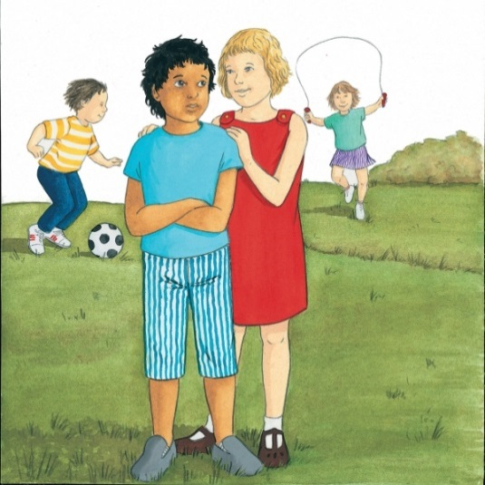
Learning Objective:
Children know and understand that God has made them unique and that although we are all different we are all special to him.

Key words:
God, wonder, love, creation, hands, fingers, nails, faces, noses, lips, ears, hair, features, colour, shape, size, unique, belonging, different, special, womb, describe, friends, generous, worried, Baptism.

Physical Does it matter if we are all different? How are we different?

Social Who do I play with at school and why does he/she play with me? Explore favourite games.

Emotional Explore how we feel about our friends at home and at school. Explore why we play with them. Who would we go to if we were worried or concerned?

Spiritual To consider: Is Jesus our friend? To share the story from scripture ‘Jesus welcomes the little children’ and talk about children being special to God.
What celebrations do we enjoy in our family and our church?
Who is the Mother of Jesus? Why is she special? To know that Jesus grew for nine months in Mary’s womb.
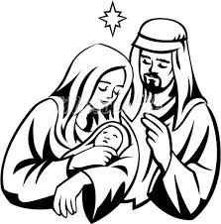
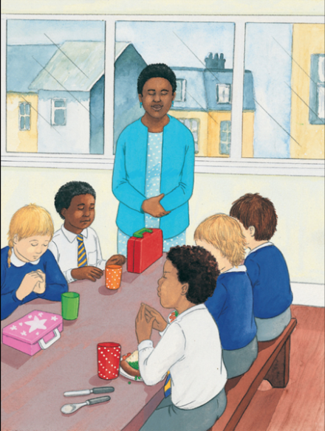
Year One – We meet God’s love in our family
Children know and understand that they are growing and developing as members of their own family and God’s family.

Key words:
unique, friend, respect, secure, God, love, care, commitment, stable, important, different, special, signs, healthy, safe, boundaries, kindness, teasing, bullying, positive, negative, wrong, acceptable, truth, lie, head, eyes, nose, mouth, teeth, tongue, throat, neck, shoulders, arms, breasts, nipple, waist, elbow, penis, vagina, bottom, anus, legs, knees, ankles, toes, feet

Physical Who is in my family? E.g. mother, father, brothers, sisters, grandparents etc. What makes my family a happy family? How does my family keep me healthy?

Social How are the words please and thank you important to my family? How does saying sorry show respect to others?

Emotional Why is teasing and bullying wrong? Why should we always tell the truth?

Spiritual We are members of God’s family. How were we born into God’s family?
What special title do we give to God as members of God’s family? How does the story of The Lost Sheep help us to understand God loves and cares for us? How shall we thank God for unconditional love?
Year Two – We meet God’s love in the community
Children know and understand that they are growing and developing in a God-given community.

Key words:
God-given, community, local, global, impact, responsibility, harm, improve, belonging, family, diverse, father, mother, carer, guardian, feelings, recognize, emotions, friendships, relationships, secrets, stereotypes, respect, equal.

Physical What keeps us safe in our communities? What would we do if we felt unsafe? Who is an appropriate adult to talk to? How do I keep myself safe online? Is all the information I see online true?

Social How would you describe a community?
What are the joys of belonging to a community?
How do different individuals enrich our community?

Emotional How do we learn from each other and show an understanding for the different roles and responsibilities people have in their communities?
What do you bring to the communities you belong to?

Spiritual How do we learn from each other and show an understanding for the different roles and responsibilities people have in their communities?
What do you bring to the communities you belong to?
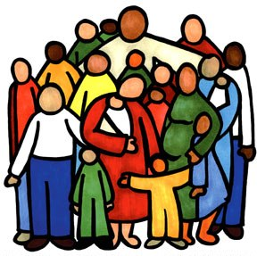
Year Three – How we live in love
Children know and understand the virtues essential to friendship, e.g. Loyalty, responsibility… and experience the importance both of forgiving and being forgiven and of celebrating God’s forgiveness.

Key words:
Community, God-given, belonging, family, diverse, father, mother, carer, guardian, feelings, emotions, friends, loyalty, kindness, trust, selfless, generous, reasons, difficulties, positive, respectful.

Physical What things trigger disagreements between friends and within friendship groups? How do these make people feel?
What might be the best way to resolve conflict in friendships?
Healthy friendships make people feel included; how should we react if we see others feel lonely of excluded? Why is violence never the answer?

Social How do friendships make us feel happy and secure? Who would you turn to if you didn’t feel safe in a friendship? What is the difference between a relative, a friend and an acquaintance?

Emotional How would you respond to an adult you did not know who made you feel uncomfortable or unsafe? What are the qualities of a true friend?
How can friendships change?

Spiritual
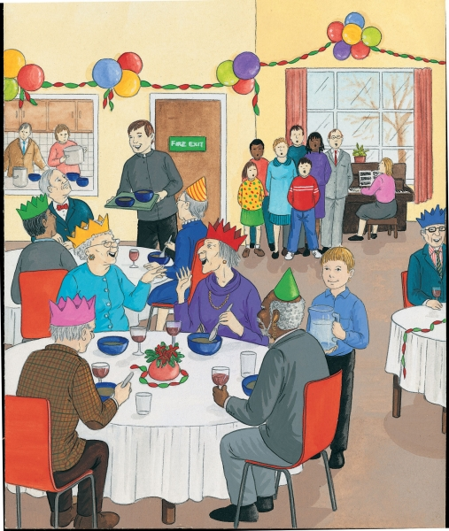
How does the gift of the Sacrament of reconciliation help restore friendship with God and others?
How can these words inspire, help and guide us to improve our friendships?
What bible stories teach us about the beauty of forgiveness?
What does the phrase to err is human, to forgive divine mean to you?
St Francis De Sales said ‘a quarrel between friends when made up, adds a new tie to the relationship.’ How would you explain this to your friends and others?

Year Four – God loves us in our differences
Children know and understand that they are all different and celebrate these differences as they appreciate that God’s love accepts us as we are and as we change.

Key words:
Gifts, talents, difference, development, change, conflict,
appreciate, celebrate, stereotype, acceptance, cultural, biological, respect, courtesy, manners, sensitivity, religious, belief, bullying, polite, uniqueness, innate, beauty, dignity.

Physical How do we respect others, even when they are different from ourselves: physically, ethnically, culturally or in spiritual beliefs?
In what ways can we expect to be treated with respect by others and in turn show our respect? How can we challenge the stereotypes that encourage bullying? How could challenging a friend to do something you would not like to do challenge the Golden rule ‘treat others as you would like them to treat you’?
How can we recognize the innate dignity of every person and ask God to help us see it?

Social Is there more to courtesy and manners than please and thank you?
In what ways are being polite and courteous helping to make the world a better place to live in? How would you ensure that you have a part to ply in keeping yourself and others in your family and community safe?

Emotional How do authority figures help communities and societies work together better? How should we include everyone and celebrate each other’s differences in schools, homes and communities?

Spiritual What makes you unique? What are your special qualities, gifts, talents? What attributes do others recognize in you? Why are being honest, truthful and having integrity positive attributes? How can you use your gifts for the Common Good? What can we do for each other to support each other’s mental health and well-being, recognizing the importance of expressing feelings?
Year Five – God loves us in our changing and developing
Children know and become aware of physical and emotional changes that accompany puberty – sensitivity, mood swings, anger, boredom etc. and grow further in their understanding of God’s presence in their daily lives.

Key words:
God, sensitivity, puberty, presence, celebrate, external, internal, change, develop, menstruation, ovulation, production, reproduction, hormones, menstrual cycle, pituitary gland, uterus, fertilized ovum, fallopian tube, vagina, cervix, womb, period.

Physical How do we recognise the emotional, internal and external changes that happen during puberty? Why do we think we might need to change our hygiene routines during puberty; why is it important to maintain a good personal hygiene? How do we know what physical contact is appropriate, inappropriate or unsafe? As we grow and change, how do we recognize the God of love who journeys with us?

Social and Emotional How do you recognize you are growing and developing? Do you think these changes have affected your friendships? How?
Are these determined by how others treat you?
Are there ways you are becoming sensitive to your emotional development and that of others?
If a friend was struggling with their self confidence and self esteem, what would you advise them to do?
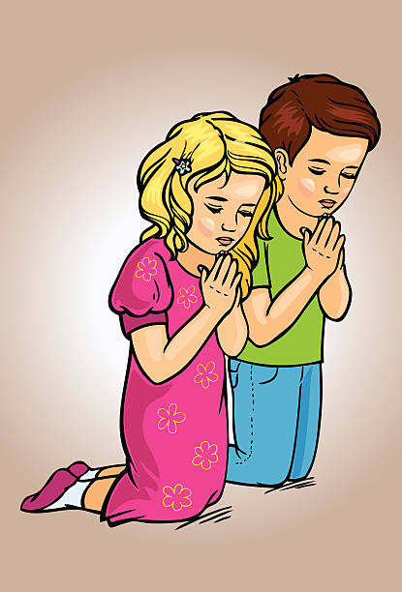
Where would you go for advice or to report concerns for yourself or on behalf of a friend because you are worried about being unsafe, feeling uncomfortable or concerned for your own or their mental health and wellbeing?
How can this translate to keeping safe online?

Spiritual What does to mean to grow holistically?
Are there ways and means we can ensure each aspect happens healthily? What difficulties might you face as your body changes and grows? God’s love surrounds you and His Holy Spirit guides and protects you. How will this help you to be respectful of your own body and help you to be courageous in the face of changes?
Year Six – The wonder of God’s love in creating new life
Children develop in an appropriate way for their age, an understanding of sexuality and grow further in their appreciation of their dignity and worth as children of God.

Key words:
God, Christian, appropriate, dignity, sexuality, intercourse, fallopian, conceive, relationship, uterus, cervix, fiancé, fiancée.

Physical What are the key building blocks to a loving relationship? How does conception take place?

Social and Emotional What does it mean to be patient, kind and never jealous? What does it mean to not be boastful, conceited, and to never seek advantage?
What does it mean to not take offence, store up grievances or rejoice at wrongdoing?
Explain what it means that love finds joy in the truth, is always ready to make allowances, endure whatever comes and never comes to an end?

Spiritual What are the characteristics of positive respectful relationships? (inc use of social media) When building relationships online how can we recognise risks such as appropriate images, language and behavior –and how would we report these? What sorts of boundaries are appropriate in friendships with peers and others inc in a digital context? If boundaries have been crossed, who do we contact to report this and how do we get advice?
How can we ensure we are contributing to the wellbeing of others and taking steps to avoid the negatives? How would this impact on building positive relationships? How can we discover the presence of God in family and friends?

We praise and thank you, Lord, for gifts of life and love.
Help us to use these wisely as we continue to journey in love.

