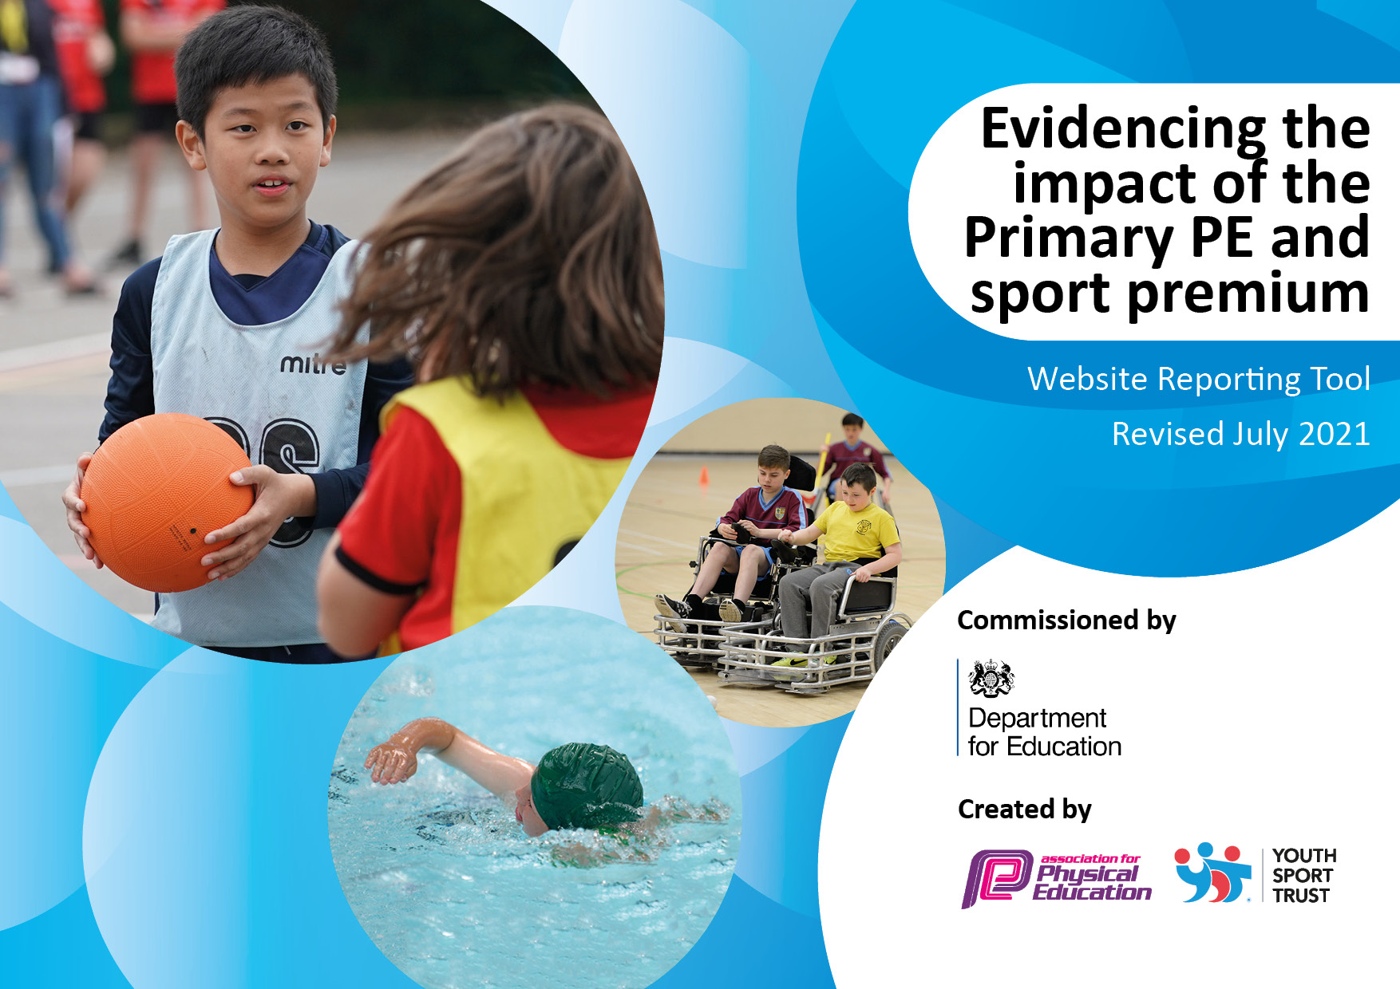
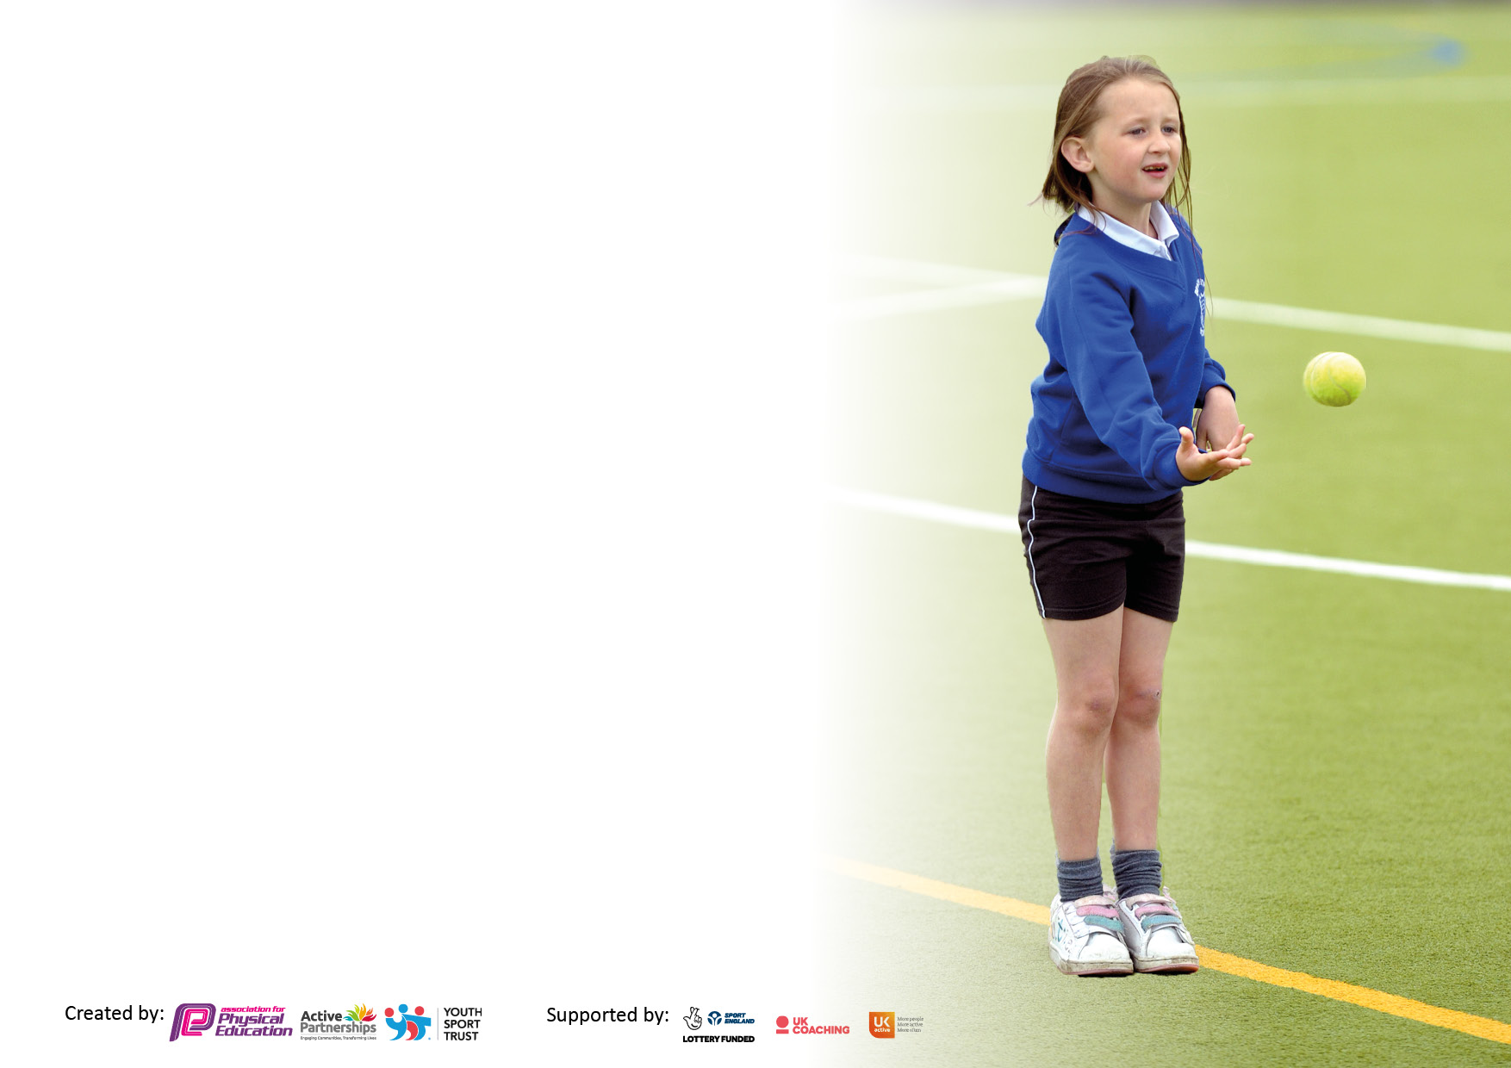

It is important that your grant is used effectively and based on school need. The Education Inspection Framework makes clear there will be a focus on ‘whether leaders and those responsible for governors all understand their respective roles and perform these in a way that enhances the effectiveness of the school’.

Under the Quality of Education Ofsted inspectors consider:
Intent - Curriculum design, coverage and appropriateness
Implementation - Curriculum delivery, Teaching (pedagogy) and Assessment
Impact - Attainment and progress

To assist schools with common transferable language this template has been developed to utilise the same three headings which should make your plans easily transferable between working documents.

Schools must use the funding to make additional and sustainable improvements to the quality of Physical Education, School Sport and Physical Activity (PESSPA) they offer. This means that you should use the Primary PE and sport premium to:

- Develop or add to the PESSPA activities that your school already offer
- Build capacity and capability within the school to ensure that improvements made now will benefit pupils joining the school in future years
- The Primary PE and sport premium should not be used to fund capital spend projects; the school’s budget should fund these.

Pleasevisitgov.ukfortherevisedDfEguidanceincludingthe5keyindicatorsacrosswhichschoolsshoulddemonstrate animprovement.Thisdocumentwillhelpyoutoreviewyourprovisionandtoreportyourspend.DfEencouragesschools to use this template as an effective way of meeting the reporting requirements of the Primary PE and sport premium.

We recommend you start by reflecting on the impact of current provision and reviewing the previous spend.

Schools are required to publish details of how they spend this funding, including any under-spend from 2019/2020, as well as on the impact it has on pupils’ PE and sport participation and attainment. All funding must be spent by 31st July 2022.

We recommend regularly updating the table and publishing it on your website throughout the year. This evidences your ongoing self-evaluation of how you are using the funding to secure maximum, sustainable impact. Final copy must be posted on your website by the end of the academic year and no later than the 31st July 2021. To see an example of how to complete the table please click HERE.

Details with regard to funding
Please complete the table below.

Total amount carried over from 2019/20 | £6700
Total amount allocated for 2020/21 | £16790
How much (if any) do you intend to carry over from this total fund into 2021/22? | £7380
Total amount allocated for 2021/22 | £16,860
Total amount of funding for 2021/22. To be spent and reported on by 31st July 2022. | £24,240
Swimming Data
Please report on your Swimming Data below.

Meeting national curriculum requirements for swimming and water safety.

N.B. Complete this section to your best ability. For example you might have practised safe self-rescue techniques on dry land which you can then transfer to the pool when school swimming restarts.
Due to exceptional circumstances priority should be given to ensuring that pupils can perform safe self rescue even if they do not fully meet the first two requirements of the NC programme of study
What percentage of your current Year 6 cohort swim competently, confidently and proficiently over a distance of at least 25 metres?  N.B. Even though your pupils may swim in another year please report on their attainment on leaving primary school at the end of the summer term 2020.  Please see note above | 69%
What percentage of your current Year 6 cohort use a range of strokes effectively [for example, front crawl, backstroke and breaststroke]?  Please see note above | 62%
What percentage of your current Year 6 cohort perform safe self-rescue in different water-based situations? | 69%
Schools can choose to use the Primary PE and sport premium to provide additional provision for swimming but this must be for activity over and above the national curriculum requirements. Have you used it in this way? | Yes/No

Action Plan and Budget Tracking
Capture your intended annual spend against the 5 key indicators. Clarify the success criteria and evidence of impact that you intend to measure to evaluate for pupils today and for the future.

Academic Year: 2021/2022 | Carried Over 20/21: £7380  Total fund allocated: 16,860  Total to Spend: £24,240 | Date Updated: 17th July 2022
Key indicator 1: The engagement of all pupils in regular physical activity – Chief Medical Officers guidelines recommend that primary school pupils undertake at least 30 minutes of physical activity a day in school |  |  |  | Percentage of total allocation:
 |  |  |  | %
Intent | Implementation |  | Impact
Your school focus should be clear what you want the pupils to know and be able to do and about  what they need to learn and to  consolidate through practice: | Make sure your actions to achieve are linked to your intentions: | Funding allocated: | Evidence of impact: what do pupils now know and what can they now do? What has changed?: | Sustainability and suggested next steps:
Headline Intended Impact on  Pupils – All pupils will be active on average for 60 minutes per day.  To provide all pupils with high quality, progressive PE and sport in school. Children will benefit from good quality teaching from PE specialist and teachers.  To provide a range of activities - implementation of new extracurricular timetable. Increase the number of clubs for children and promote physical activity during break times and after school.  To enhance/develop physical activity (outdoors) through forest school CPD - Forest Schools.Com (Ormskirk) and Camp Curiosity. In addition, to purchase equipment to facilitate forest school (whole school to access) with weekly opportunities for forest school provision across the school.  KS2 children to participate in a ‘Commando Joe’s programme. The primary aim is to enhance/develop physical skills along with supporting character building, increasing citizenship, engaging with physical challenges, supporting communication, collaboration and critical thinking skills, especially preparing pupils for their transition to secondary school.  Audit of PE equipment and playground equipment to encourage physical activity. | Increasing the range of physical activities and clubs provided;  - Staff provided with weekly CPD training from LFC professionals.  - Children from YR1-Y6 are provided with 1hr high quality PE session with LFC.  - From Spring term 2 (due to COVID restrictions) to provide after school clubs to promote/encourage physical activities e.g. ballet, outdoor learning, cricket, netball, multi skills (as part of CWG 2022) etc.  - To participate in a whole school, skipping workshop, encourage and promote skipping at break and lunch times along with taking part in National Skipping Day 25th March 2022).  - Work and liaise with Focus Gymnastics to provide CPD for teachers and gymnastics lessons for children along with an after school club for KS2.  - Sports leaders (KS2) to encourage/support children (lunch times) to engage with physical activities.  - Pupil Voice - to assess physical activities available at lunch times and consider requests/order equipment where necessary to promote physical activity based on interests.  - After completion of ‘Forest School’ training, forest school weekly opportunities provided for the whole school, which increases active learning for all pupils.  - KS2 children to participate in the ‘Commando Joe’ programme on 15th July 2022 to increase physical activity along with wellbeing.  - Pupils were asked (pupil voice) the activities they would like to engage with during PE lessons and break times including ASC. In addition, all staff were asked (teacher voice), what equipment was required for break time and PE lessons including sporting competitions. | £2250 (LFC)  £234 (skipping workshop)  £32.85 (skipping ropes ordered)  Focus gymnastics £25 per hour for summer term 2 – plan 1-4pm (Monday’s) – 7 weeks = £450 (with provision of an ASC).  Forest School Expenditure  ForestSchool.Com (Ormskirk) – CPD (£997 per teacher) x 2 (EYFS & KS1) = £1994  Camp Curiosity £900 (9 weeks)  Fire Pit purchase £196.75 (excluding VAT)  £49.99 Fire Pit Cover  Slackline hammock x 2 £25.98  Green Earth Learning forest school resources (e.g. educational learning resources for activities) £104  Training Line £54.99  Outdoor compost toilet £2210  £25 Burns kit  £1150.39 Muddy Faces (Forest school kit including seating)  £159.34 Forest School books  £40.37 Outdoor Waterproof clothing  £25.08 Fire gloves & knife sharpening block  £29.95 Bush Box  £32.98 Netting Swing  £20.93 Button Swing Seat x 2  £500  £181 order for cones, bibs and team bands  £251.69 order for balls, beanbags, ankle skips and javelins | - LFC provided weekly lessons across KS1 and KS2. Children received high quality lessons in PE each week whilst developing their teamwork and collaboration.  - Staff received high quality CPD to use in lessons and after school club.  - LFC facilitated a fantastic sports day on Thursday 7th July 2022 for EYFS, KS1 and KS2. The two sessions (am & pm) were filled with fun sports and active games that were inclusive for all children. This also incorporated the ASC theme linked with CWG 2022.  - LFC facilitated an inter sports competition with a local primary school which engaged pupils from KS1 and KS2. Children took part in a competitive game, which supported the development of a range of skills as per PE curriculum.  - From summer term 2, we have been able to provide a lunch club (provided by LFC) to encourage children to be active during lunch times.  - From spring term 2 (through to summer term), after school clubs commenced (due to COVID restrictions). Clubs available were ballet, outdoor learning, gymnastics, multi sports (as part of CWG 2022) etc. Children learnt a range of skills and engaged in competitive sports.  - Children participated in the whole school skipping workshop on Friday 11th February 2022 (to develop skipping skills).  - Skipping ropes were purchased and used during break and lunch times. Children increased their skipping skills through practice and engaged in competition with peers (recording scores).  - All children participated in ‘National Skipping Day’ (25th March 2022). Certificates received for participation.  - Focus gymnastics – Children have developed their gymnastic skills with a trained coach. Teachers have received CPD to support and enhance the teaching of future gymnastics lessons.  - KS2 sports leaders have gained experience in supporting children with physical activities along with developing their leadership skills.  - Each year group has participated in weekly forest school opportunities (Camp Curiosity). This outdoor learning/physical activity experience has provided teacher’s with valuable CPD for planning and facilitating future forest school/outdoor learning experiences along with children engaging in forest school provision to enhance their physical skills and support wellbeing/mental health (holistic development). For example, the regular exposure to the natural environment has had a positive effect (observed by staff) on children’s emotional and physical wellbeing. In addition, the purchase of the outdoor toilet has enabled pupils to remain outdoors for longer periods of time, engaging with forest school activities. A future plan is to involve the pupils in the maintenance of the compost toilet, which connects physical activity with science (sustainability and environment) and supports the school’s vision of promoting more engagement in outdoor/physical learning initiatives.  - KS2 pupils engaged in the ‘Commando Joe’ programme on Friday 15th July 2022. Through observations, children gained a range of skills and expressed their enjoyment in the physical activities provided. YR6 gained skills to prepare them in transitioning to secondary school.  - Children participated in competitive games including an inter sports competition, which the new resources were used. There has been an uptake of physical activity during break and lunch times (new equipment used). New resources were used during the sports day, which enhanced a range of physical skills such as javelin. In addition, plans have been made for 22/23 academic year for new sporting activities, using purchased equipment. | - From pupil voice, continue to increase a range of physical activities at break and lunch times (order equipment where necessary).  - From pupil and teacher voice, continue to work and liaise with external providers for CPD and physical opportunities for children e.g. cricket, gymnastics, tennis etc.  - Develop/support a team of sports leaders (KS2 to allocate 2 children per class across the school – KS1/KS2).  - Due to the success of ASC linked with CWG 2022 we will aim to develop a range of ASC provision for 22/23 incorporating competition, to increase the uptake of participation.  - To continue encouraging a range of physical activities during break and lunch times. In addition, promote ASC for all pupils.  - To create a forest school provision for all year groups. To create a timetable to ensure all year groups are participating in regular outdoor/physical activities including orienteering.  - To purchase resources to deliver our own ‘Commando Joe’ style provision as pupils thoroughly engaged with the experience (increasing skills and confidence) and teachers gained CPD to develop their confidence in delivering a future programme.  - To continue to audit the PE resources at regular intervals and order where necessary.
To enhance/develop physical activity/EYFS physical development and provide CPD for teachers to facilitate their own ‘music and movement’ future lessons, across nursery and reception classes. | - EYFS children will engage with weekly ‘Music and Movement’ sessions along with the teacher receiving CPD to be able to plan future lessons. | £750 (10 weeks) Autumn term Nursery)  £750 (10 weeks) Autumn term Reception) | EYFS pupils engaged with the weekly sessions. Teachers received CPD and were provided with a bank of resources to continue using with children to enhance/support physical development for all pupils. Children have learnt a variety of physical movements and have gained confidence in engaging with dance. | To continue using the physical activities to enhance/promote physical development (EYFS). Teachers to engage with further CPD in the next academic year to increase knowledge and skills in facilitating ‘Music and Movement’ sessions.
Key indicator 2: The profile of PESSPA being raised across the school as a tool for whole school improvement |  |  |  | Percentage of total allocation:
 |  |  |  | %
Intent | Implementation |  | Impact
Your school focus should be clear what you want the pupils to know and be able to do and about  what they need to learn and to  consolidate through practice: | Make sure your actions to achieve are linked to your intentions: | Funding allocated: | Evidence of impact: what do pupils now know and what can they now do? What has changed?: | Sustainability and suggested next steps:
Introduce PE and school sport to celebration assembly every term to ensure the whole school is aware of the importance of PE and sport and to encourage all pupils to aspire to being involved in the assemblies. | - Outside school achievements to be celebrated during celebration assemblies to increase interest in joining sports clubs.  - Classes to display PE learning during class assemblies e.g. dance/gymnastics.  - Any PE achievements to be celebrated e.g. gymnast of the week or person of the match.  - Celebrate achievements during active clubs and LFC sessions. | £ N/A | Due to COVID restrictions whole school assemblies have not took place. However, from Summer term 2 (as part of the Commonwealth Games), we organised a whole school assembly to introduce the theme and explain how the school would be participating through ASC. Children were divided into four teams (England, Scotland, Wales and Northern Ireland). Each week they completed a range of planned physical activities and points were collected, shared and celebrated each week. Sports Day was also incorporated to this event. The winning team received a reward, shared at a celebration assembly at the end of the school year/competition.  We have also created, in the main corridor, a wall to share and celebrate physical activity achievements. The plan is for assemblies to return in the next academic year. | With restrictions easing, the plan is to raise the profile of sport and physical activity through assemblies and planned events similar to the CWG 2022 event. In the next academic year, to plan ASC with a similar theme as this has been successful in increasing interest and engagement in sport/physical activities.
Promote and celebrate physical activity. | - Create a St Augustines PE Twitter page to promote and celebrate physical activity.  - Organise for pupils to bring in photographs/awards/trophies to be shared in class and on the celebration wall (main corridor). | £ N/A | School PE Twitter page created Autumn term to share physical activity in school. This is regularly updated with events, participation etc (to raise the profile of PE and share with parents, stakeholders etc.) | Continue sharing physical activity (in school) on the school PE Twitter page along with celebrating outside achievements in school, especially assemblies once reinstated.
Develop a team of ‘Sports Leaders’ (KS2) who will support/enhance physical activity during lunch times. | - Sports Leaders (KS2) to be chosen by SLT and provided with support/training to enhance/develop physical activity during lunch times. | £ N/A | Sports leaders appointed by SLT. Children have took responsibility to fulfil their roles. Children have received support from sports leaders, which has increased uptake of physical activity during break and lunch times. In addition, a variety of new equipment (purchased) has been used to increase interest in a range of physical activities. | New sports leaders will be appointed (by SLT) in the next academic year. The appointing of sports leaders has increased interest and uptake of physical activities during break and lunch times so this will continue next year. Sports leaders have also gained leadership skills.

Key indicator 3: Increased confidence, knowledge and skills of all staff in teaching PE and sport |  |  |  | Percentage of total allocation:
 |  |  |  | %
Intent | Implementation |  | Impact
Your school focus should be clear | Make sure your actions to | Funding | Evidence of impact: what do | Sustainability and suggested
what you want the pupils to know | achieve are linked to your | allocated: | pupils now know and what | next steps:
and be able to do and about | intentions: |  | can they now do? What has
what they need to learn and to |  |  | changed?:
consolidate through practice:
Headline Intended Impact on Pupils – All pupils’ will receive high quality physical education and physical activity lessons every week. 100% of pupils to develop their physical, cognitive, social and emotional skills/learning. This is supporting the target for all pupils to be active on average 60 minutes a day. Teacher’s to be supported with CPD to increase confidence, knowledge and skills when teaching PE and sport.  Through teacher voice, to provide gymnastics CPD training for all staff to increase confidence and subject knowledge for delivering/facilitating future lessons. | Teaching staff to receive CPD from LFC for PE and sport activities (every week).  Teaching staff to receive CPD from ‘Camp Curiosity’ for forest school learning activities. In addition, two staff to attend forest school training (achieve level 3 qualification) Omskirk.  Teaching staff to receive CPD from ‘Focus Gymnastics’ for planning and facilitating future gymnastic lessons.  From CPD and support from PE subject leader, teacher’s to ensure that pupils within their class are active on average 60 minutes per day through planned:  - PE lessons  - Outdoor learning sessions  - Active maths  - Break and lunch times  PE subject leader to plan additional events to increase children engaging with physical activity and support teacher in delivering sporting activities and events.  PE subject leader to assess and circulate the training documents for the Enrich orienteering course (once it has been fitted in July 2022), so that it can be used regularly in the next academic year. | £ LFC £ See costing indicator 1  £ Camp Curiosity £See costing indicator 1  £ Forest school training – Ormskirk £ See costing indicator 1  Gymnastics CPD £ See costing – indicator 1.  Enrich Orienteering – course installed July 2022 – see costing indicator 4 | Teaching staff have increased skills and confidence in teaching a range of sporting activities, CPD provided by LFC. Teaching staff have used skills to support children during break and lunch times including preparation for sporting events (inter sports).  Outdoor learning/physical activity experiences have increased, which has supported the development of a range of skills for both staff and pupils. Children and staff are more confident in using the outdoor area and likewise this has increased wellbeing/mental health or all pupils. Children are engaging more with the active learning outdoors and are being exposed to a range of physical activities, which has increased their experiences and skillset.  Children have took part in a Guinness World Book skipping event, a CWG 2022 sporting event which was also shared with parents (whole school and community event). Children have developed their confidence in competing against other schools through planned competitive sporting events.  Children will access the orienteering course as part of PE and physical activity planned lessons. Evidence will be documented on the next Primary PE and Sport Premium report. Course paid for this academic year due to it being fitted the end of July 2022. | Through teacher voice and pupil voice, PE subject leader has planned/booked CPD for cricket, tennis and gymnastics in the next academic year. The next steps is to increase uptake of interest in those sports, teachers to gain confidence in teaching lessons and children to gain new skills to be able to engage in the sport and also compete against other schools (inter sporting events).  Outdoor learning to be promoted and increased for all classes. Any opportunity to take learning outdoors encouraged. Children to regularly access the outdoor areas to increase active learning experiences. Forest school provision has been purchased, so that outdoor learning can take place in all weathers.  PE subject leader to continue actively increasing additional sporting/physical activity events by working closely with SGO, LFC and other external providers and circulating to all staff and organising events.  Children to actively access the Enrich orienteering course, supported by teaching staff.
Key indicator 4: Broader experience of a range of sports and activities offered to all pupils |  |  |  | Percentage of total allocation:
Intent | Implementation |  | Impact
Your school focus should be clear | Make sure your actions to | Funding | Evidence of impact: what do | Sustainability and suggested
what you want the pupils to know | achieve are linked to your | allocated: | pupils now know and what | next steps:
and be able to do and about | intentions: |  | can they now do? What has
what they need to learn and to |  |  | changed?:
consolidate through practice:
Additional achievements:  Headline Intended Impact on Pupils – All pupils’ will be exposed to new areas of activity. Supporting the target for all  pupils to be active on average 60  minutes a day.  PE subject leader to continue to offer a wider range of activities both within and outside the curriculum in order to get more pupils involved in active learning, sports and physical activity. | - To complete a pupil survey to see what sports/clubs children would like to take part in (once clubs commence from COVID restrictions).  - External coach (Focus gymnastics) to teach along with a teacher (CPD) a KS2 extra-curricular club – summer term 2.  - To provide whole school with a skipping workshop to broaden physical activity experiences and develop physical skills.  - To provide whole school with an active ‘circus skills’ session to broaden physical activity experiences and develop physical skills.  - To provide whole school with an ‘archery skills session to broaden physical activity experiences and develop physical skills.  - Enrich Education to install and provide a school orienteering package/resources to enhance physical activity across the whole school (orienteering course including connecting physical activity with other curriculum areas - maths, English, geography etc). As a result, this will promote and enhance the provision of outdoor physical and adventurous activities. | N/A  See costs in indicator 1.  See costs in indicator 1.  £300  £300  £1710 | Through discussion (pupil voice), pupils know what sporting/physical activities they would like to engage with. From this, the PE subject leader has begun to plan future learning and experiences e.g. gymnastics, tennis, orienteering, cricket etc.  Children have increased their skills in skipping – participating in two events (World skipping day and Guinness Book of Records – 24th June 2022). There has been an uptake of skipping during break and lunch times.  Children gained new skills in circus skills and archery. | For 22/23 academic year, PE sports leader has organised for cricket and tennis coaching including teacher CPD, so that children will be confident in teaching those sports in future lessons and the children will be receiving a quality learning experience.  Through assessing quality of gymnastics provided by ‘Focus Gymnastics’ and discussing with teachers, their confidence in teaching gymnastics, we have decided to continue with gymnastics coaching (by a trained coach – member of British Gymnastics Association) so that both teachers and children are receiving quality training and learning. Booked for Autumn term 1, 2 and summer term 2.  Children will be encouraged to engage with skipping during lunch and break times to continue practising/improving their skills.  Orienteering course to be actively used on a regular basis in the 22/23 academic year.

Key indicator 5: Increased participation in competitive sport |  |  |  |  |  | Percentage of total allocation:
 |  |  |  |  |  | %
Intent |  | Implementation |  |  | Impact
Your school focus should be clear |  | Make sure your actions to | Funding |  | Evidence of impact: what do | Sustainability and suggested
what you want the pupils to know |  | achieve are linked to your | allocated: |  | pupils now know and what | next steps:
and be able to do and about |  | intentions: |  |  | can they now do? What has
what they need to learn and to |  |  |  |  | changed?:
consolidate through practice:
Headline Intended Impact on Pupils – Increase the number of pupils participating in an increased range of competitive opportunities Supporting the target for all pupils to be active  on average 60 minutes a day.  Be part of school games and engage in physical activity opportunities where possible (inter competitions)  Increased participation in intra- competitions |  | - To attend/participate at ‘Halton School Games’ events/competitions (compete against local schools).  - Competitive games introduced in active/sporting clubs and during LFC weekly lessons. | £594  See costing LFC – indicator 1 |  | - KS2 represented the school at the Runcorn swimming gala (9th March 2022).  - KS2 represented the school at the Diamond Cricket event (28th April 2022).  - Whole school participated in a Commonwealth Games 2022 event. This was during after school club and incorporated sport day. Whole school divided into 4 teams (England, Northern Ireland, Wales and Scotland). The winning team (Wales) was announced at a celebration event on Wednesday 13th July 2022.  - Whole school sporting event held with Astmoor Primary School (hosted by St Augustine’s) on Thursday 14th July 2022.  - Through participation and commitment to physical activity and sports – PE subject leader successfully applied (on behalf of St Augustine’s) for the Gold Award – School Games Mark, which was achieved in July 2022. | To continue engaging with Halton School games activities/events.
Retain gold mark in school games award. |  | - Increased participation in competitions (intra and inter).  - Share success with parents (via Twitter feed).  - Attend CPD training – subject leadership | See costing indicator 5. |  | - Children have participated in a KS2 swimming gala, KS2 Diamond Cricket event and an inter schools competition with Astmoor Primary School.  - Twitter feed updated with physical activity in school along with competition participation.  - PE subject leader attended CPD training – Bootle and training notes/info added to teacher drive.  - School achieved gold mark – School Games Mark – July 2022. | To apply for gold mark again in 22/23 academic year.
Signed off by
Head Teacher:
Date:
Subject Leader: | Helen Owen
Date: | 17th July 2022
Governor:
Date:

