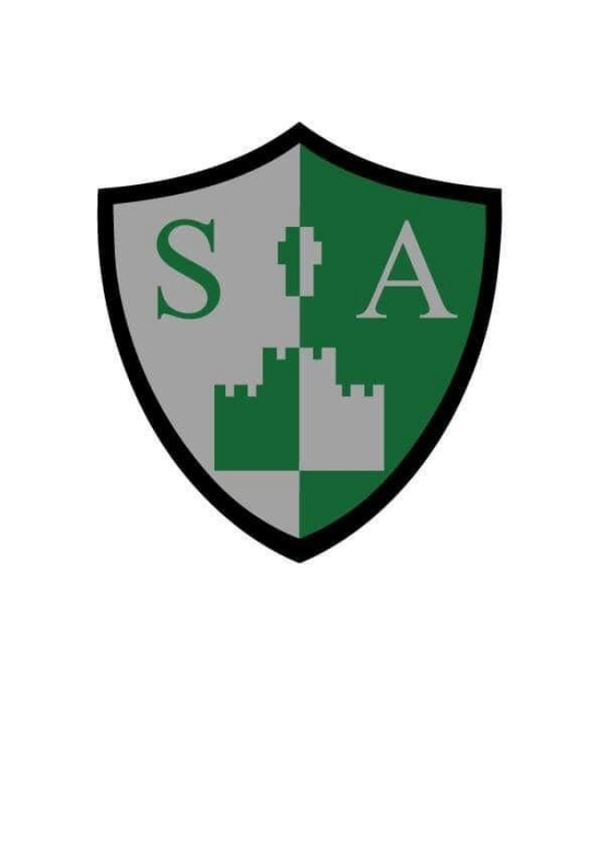

St Augustine’s Catholic Primary School and Nursery

**WRITING STATEMENT OF INTENT**

**Intent**

At St Augustine’s we are working hard to provide our children with rich and varied learning opportunities that help them to become confident and enthusiastic learners. Throughout the school we aim for the children to develop an awareness of the audience, purpose and context when writing. We ensure meaningful and purposeful writing tasks are planned, to give a reason for writing. As a school we use a Mastery and text-based approach to writing to ensure progressive and systematic teaching of skills across the curriculum. Throughout each year and across the school these skills are repeated to ensure children are able master and apply these skills independently. Writing is taught through high-quality picture books incorporating fiction and non-fiction. Teachers also carefully choose and weave in high quality texts across all subjects to support and develop children’s vocabulary and encourage children to make cross curricular links. Across the school, children use the skills learnt in their English lessons and apply these in their topic writing. Across the school, spelling and grammar sessions are weaved into each unit within the English lessons. In Key Stage 2 children also have standalone spelling and grammar lessons. ‘Talk for Writing’ is incorporated into our English curriculum in order to allow children to become story tellers and makers. Children enjoy book talk which allows them to explore personal and collective responses to a text. Children orally rehearse stories and perform them to the rest of the class. This then supports children in the writing process, especially in EYFS and Key Stage 1 when they are asked to modify and innovate stories to make them their own. At St Augustine’s we want our children to have a positive attitude towards writing, to be able to independently express their emotions and share their ideas. When the time comes our children leave us we want them to be able to write as authors and poets and have developed a life-long love for writing.

**Implementation**

At St Augustine’s we want all of our pupils to be capable readers, writers, spellers and speakers, who can transfer their English skills to other curriculum subjects and who are prepared for the next steps in their education. Our English lessons develop pupils’ spoken language, reading, writing, grammar and vocabulary. Writing is taught through a mastery approach, were the children are taught skills progressively and systematically. These skills are repeated to ensure children are able master and apply these skills independently.

We teach our pupils to speak clearly, to convey their ideas fluently and confidently and to ask questions. We know the value of excellent vocabulary and this is developed and practised across our curriculum. In EYFS and Key Stage 1 we use ‘Talk for Writing’ to encourage pupils to express their ideas, discuss their ideas and to develop more sophisticated vocabulary. We develop writing skills and have built in repetition within our units so that our children have the stamina and ability to write at the age expected standard by the end of the year. To support children in moving towards independent writing we provide a wide range of activities including the use of film and imagery, music, ICT, modelled, shared and guided writing, peer assessment and discussion. We provide varied and exciting opportunities for writing for purpose and we encourage pupils to see themselves as authors and poets. We promote the importance of written work by providing a writing purpose and opportunities for children’s writing to be read aloud and listened to by an audience. Across the school writing is taught daily. Early writing is taught through early mark making, then when the children begin RWI phonics they are taught the letter formations. This begins with writing (whether with a writing tool or in the air) CVC words, moving onto short sentences using the sounds they have been taught. The children are also encouraged to write independently in continuous provision. In Key Stage 1 this is then developed and handwriting sessions are regularly incorporated into the English lessons as well as RWI phonics. In Key Stage 2 handwriting is incorporated into weekly English lessons and standalone daily 10 minute lessons. Spelling and grammar is taught throughout each English unit across the school. In Key Stage 2 standalone daily lessons are also taught for 15 minutes (3 grammar and 2 spelling lessons).

**Impact**

At St Augustine’s we measure the effectiveness and impact of our English Writing, Grammar and Spelling curriculum in a variety of different ways. Assessment for learning strategies are used on a daily basis. These will allow a picture to be built up of the pupils’ progress, any areas of strength or weakness which can then be addressed in teachers’ planning accordingly. We use National and summative testing to assess pupils' outcomes for Grammar, Punctuation and Spelling as part of the Statutory Assessment Tests (SATs for Year 2 and Year 6 pupils) and through termly summative assessments across school which enables pupils' progress and attainment in the subject matter to be evaluated. Additionally, pupils complete writing assessments on a half termly basis, where written work is assessed to inform teachers of pupils' next steps and successes. Half-termly, teacher’s also moderate pupils work in school and in cluster meetings with other schools to ensure accurate assessments are being made across the school. The quality of writing in English and knowledge books is evaluated by drop ins, pupil interviews, conversations with teachers and work scrutinies. These inform future areas for improvement and the impact of new initiatives.