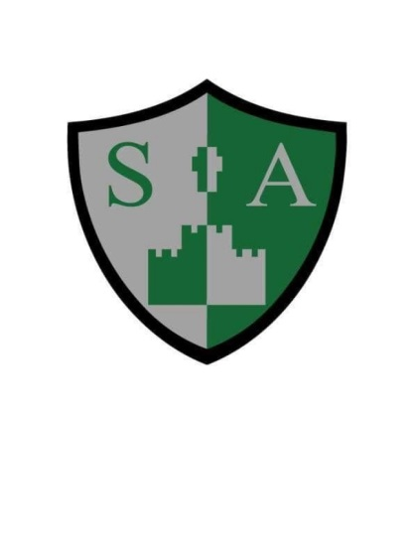

St Augustine’s Catholic Primary School and Nursery

**READING STATEMENT OF INTENT**

At St Augustine’s we intend to:

* Ensure the foundations for becoming life-long readers are set as soon as children enter our early year’s foundation stage. Home school partnerships are established during weekly stay and learn sessions where parents are supported in teaching their children how to read.
* Ensure children have access to a wide range of quality texts and genres which will enable them to develop a life-long love of reading.
* Choose texts which will enable children’s written and oral vocabulary to be enhanced.
* Through rigorous assessment, children will read texts matched closely to their current reading ability, meaning they make progress in the skills of fluency, accuracy and comprehension. This will enable children the opportunity to read confidently for pleasure and information to support areas of personal interest.
* At St Augustine’s we aim to develop critical thinkers. We want our children to become inquisitive readers; we encourage children to constantly ask questions about the texts they are reading, engage in debates and draw their own conclusions.

**Implementation**

* High quality texts (which form the basis of planning in all key stages) are carefully chosen to ensure children are able to build up reading skills in a progressive and sequential manner. Skills are revisited and practised regularly in a range of contexts which allows a mastery approach to the teaching and learning of reading to be achieved.
* Children listen and read stories in a range of contexts. In EYFS and year one, children take part in daily dialogic reading sessions. Children in EYFS and year one read books which match their current phonic level which will enable fluent and confident reading and equip children with the skills they need to progress into our ‘Pathways to Read approach in year two.
* From year two to year six, children follow the ‘Pathways to Read’ programme. Children receive one whole class reading lesson a week which is followed up with a guided read for each group of children. This ensures children are mastering reading skills at a level which is personalised and appropriate for them. In addition to this, there is an independent ‘follow up task’ which allows children to embed skills which have been taught through the whole class reading lesson.
* Our ‘Pathways to Read’ approach allows children to be exposed to a range of genres as well as ensuring children widen their vocabulary through being immersed into a range of high quality texts.
* Events to emphasise the importance of reading are planned for each half term. E.g. children are visited by the book bus, take part in sponsored reads, authors visit key stages and children take part in events, such as, world book day where they are taken to a local bookshop to use their book token to purchase a new book of their choice.

**All teachers:**

1. Know where all their children are, through the use of rigorous assessment, including phonics assessments and half termly benchmarking.
2. Understand where all children need to be through a secure understanding of year group expectations and ongoing formative assessment; enabling them to stretch and challenge all children, regardless of background or ability.
3. Have a clear understand of how they are going to get them there:

* Daily RWI phonic sessions in EYFS and key stage one.
* Daily dialogic reading in EYFS and Year one.
* Weekly whole class and guided reading in year’s two to six.
* Through assessment, children who are at risk of falling behind are quickly highlighted and carefully planned interventions are put in place to support these children.

**Impact**

Our aim is for all children to fulfil their potential by meeting the expected standard or above in their reading. We want to give children the opportunity to meet the next stage of their educational journey with confidence. Children’s progress is measured through continual formative assessment and through statutory assessments in key stage one and two. Progress in phonics is measured by the phonics screening check in year one. Results are measured against the reading attainment of children nationally. However, we also firmly believe that reading is the key to all learning and so the impact of our reading curriculum goes beyond the results of statutory assessments. At St Augustine’s, we know that the ability to read fluently, with understanding and for pleasure is the most important academic gift we can give to our children. By implementing a high quality reading curriculum, we hope that our children will develop a deep love of literature across a range of genres, cultures and styles.